1, 2, 3… Sing with Me!”

- Singing nursery rhymes helps children learn to count, join in with numbers, and understand “how many” things there are.
- As children sing songs where numbers go up or down, they begin to understand adding more and taking away in a fun, natural way.
- The rhythm and repetition in rhymes help children spot patterns and remember sequences, which are key early maths skills.
- Using actions while singing (like showing numbers on fingers) helps children match numbers to real objects, building strong foundations for counting.

How you can help
- Let your child help to set the table for a meal, counting out how many plates are needed and making sure that everybody has one
- Do some cooking together, weighing ingredients and counting out cups and spoonful's in a recipe
- Make counting part of everyday routine such as how many steps to bed.
- Sing number rhymes such as '5 Little duckies went swimming one day'
- Bring maths into everyday activities such as asking how many grapes would you like.
- Encourage your child to talk about their day, retelling what they have done and talking about what they will be doing tomorrow.
- Make patterns with toys for example car, bus, car, bus
Children need to understand mathematical language.
Go on a number hunt. Where can you find numbers?
Sorting out the washing. Sort the clothes into the same colours. Which clothes are big and which are small? Sort the socks into matching pairs. Count how many T shirts are in the wash.
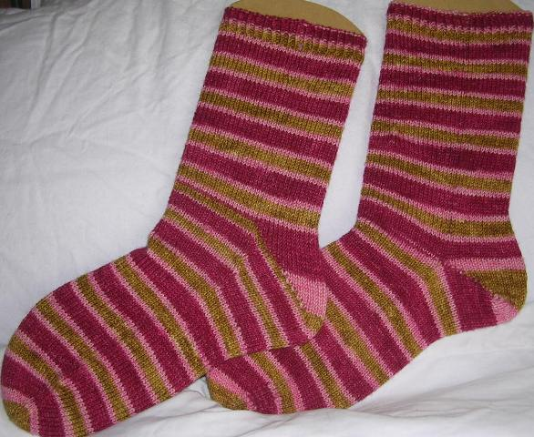
When in the bath or the paddling pool, practice pouring and filling different containers and bottles. Which container/bottle will hold the most? How do we know it will hold more than the others?
Help to water the plants in the garden, is the watering can full or empty?

Young children are learning maths all of the time through a wide variety of play experiences that start from birth. Maths is everywhere in the home and the world around us and is something that we all engage with constantly even though we may not realise it! Maths isn't just about numbers, it is also about shape and space, measures and time. Maths is about investigating and solving problems so let's have some fun with maths.

.
Let's Get Ready for School
Mathematical development
Let your child help to set the table for a meal or have a pretend picnic with their teddies…1 cup for me, 1 cup for you, 1 cup for teddy. Count how many cups you will need. 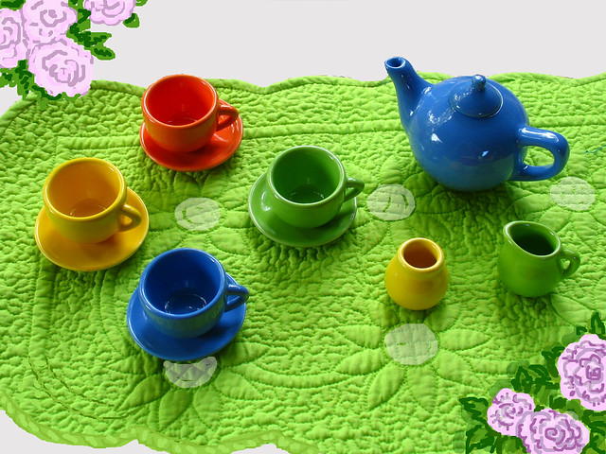

Go on a shape hunt What shapes can you see? Can you find something that is triangle shaped? You can also talk about the shapes you find, counting how many sides and corners they have. Are the sides straight or curved? Are all the sides the same length or are some shorter and some longer?
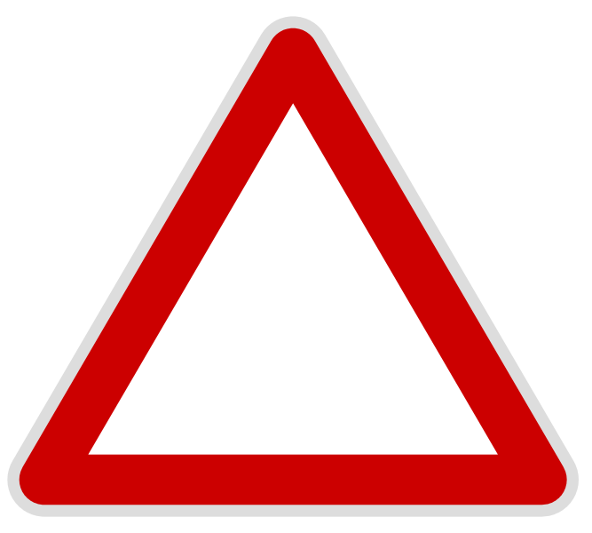

Collect some empty bottles and use them to play skittles. If your child is ready to start recognising numbers add some numbers to the skittles, if not then just count how many you knock down. You could also record how many you have knocked down using a tally chart.
