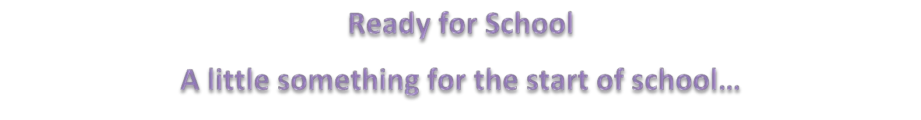


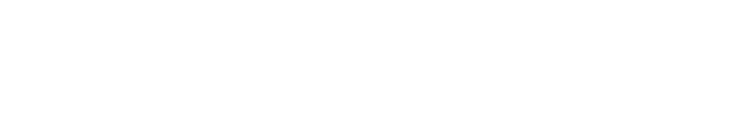

Starting school is an exciting time but it can raise questions for parents/carers and children. Look out for support materials about getting ready for school from your local Children's Centre/Family Hub Facebook Page or your Early Years Provider, who may have already been supporting some of the ideas with your child. For further information please contact the school that your child will be attending, your child’s setting or contact your local Children’s Centre/Family Hub.


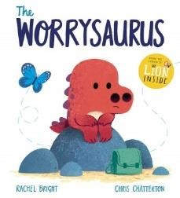

Unfamiliar situations like starting a new school or nursery can be overwhelming
for some children. Practice some effective breathing techniques with your child to help them to manage their feelings and feel calm at times of change.
(Click here to hear the story)
Breathe With Me - Guided Breathing Meditation for Kids - YouTube

Use The Worrysaurus story to talk about anything that your child might be worried about when starting school, how does the Worrysaurus get rid of his worries? Why not try a worry jar or worry monster to help your child to resolve their worries.
(Click here to hear the story) The Worrysaurus by Rachel Bright, illustrated by Chris Chatterton I Read aloud I Books about emotion - YouTube
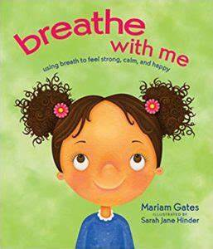
The three video clips below have been produced by the Early Years Improvement Advisors at Early Years and Childcare support. These clips offer parents simple and practical ideas of how to support their children develop a love of books. The books used within the clips might be ones that you already have at home, or you could borrow form your local library or Children’s Centre/Family Hub.
https://youtu.be/0bLxT6HfVTA - A love of books Babies

https://youtu.be/BHrhvl2-XqY - A love of books Toddlers

https://youtu.be/mskGPBb34jc - A love of books Pre-schoolers
We understand that all children develop at their own pace, and that we’re all learning from birth. When it’s time to start school, some children will need more help than others. There’s lots you can do at home to build your child’s confidence and independence, helping them feel emotionally and practically prepared to start school - Home - Starting Reception Preparing for school - Best Start in Life

