4 children LAC 2-4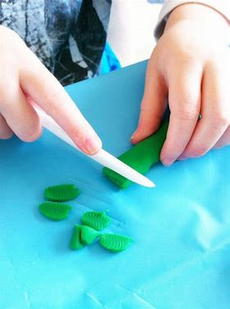
When playing with play dough use a safe knife or picnic utensils to practice 'cutting' Place your hand over your child's to guide them in moving the knife and holding the fork still.
Thread beads onto string, pasta, ribbon, pipe-cleaners
I am learning to ……
- Squeeze and roll play dough using the palms of my hands.
- Thread a bead.
- Carefully build a tower.
- Control scissors with one hand to make a snip in paper.
- Use a safe knife to cut food.
- Squeeze tweezers to pick up objects.
- Fasten and unfasten clothing such as; zip up/unzip, button up/unbutton, open & close velcro.
- Control mark making tools to make circles, lines and zig-zags such as chalk, my fingers and paint brushes.
How you can help
- Provide play dough for your child to explore – encourage squeezing, rolling, pressing using fingers, thumbs and palms.
- Encourage your child to 'take their time' 'persevere' 'concentrate' when building or threading as this can be tricky.
- Encourage your child to put on and take off clothing supporting them with fastening and unfastening zips, buttons, Velcro. Reduce frustration by 'starting your child off' and guiding them through it with lots of praise.
- Place your hand over your child's to guide them with opening and closing scissors.
- Help your child position their fingers on a mark making tool for better control.
Clothes pegs help to strengthen the muscles for fine motor control. Let your child help with squeezing the pegs when hanging clothes or provide pots to clip the pegs on to.

Fastenings on your child's clothing can be tricky at first. Provide play opportunities to practice these skills – dressing and undressing a doll or teddy. Helping an adult with their fastenings first can give children confidence but can also help your child see skill that little bit easier.

Your child can make marks using a range of tools; sticks, paint brush, feather, straw, wands, chalk.
Dip a paintbrush in a pot of water and mark make on the fence, pavement.
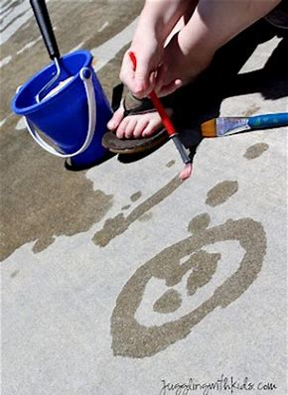
Let's Get Ready for School
Developing Fine Motor Skills
When mark-making encourage your child to make anti-clockwise circles, zig zags, up and down lines. These movements are all essential for forming letters when writing.
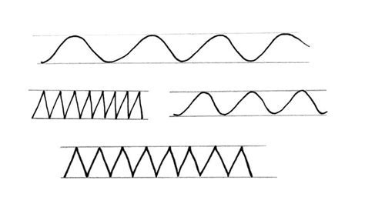
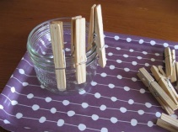
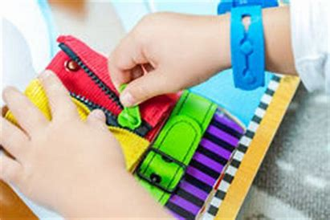
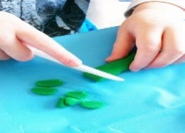
Fine motor skills involve the use of the small muscles that control the hand, fingers, and thumb. They help children perform important tasks like feeding themselves, buttoning and zipping clothes, drawing and much more. Little hands can develop dexterity and strength through practical play activities such as; play dough, safe scissors, threading, building. These will you help to prepare your child later on for holding a pencil, mark-making and ultimately writing.

Practising new skills is tricky and needs lots of time and encouragement!

